Change Log

|  |  |  |  |
| --- | --- | --- | --- |
| **Revision** | **Submission Date** | **Affected Sections or Pages** | **Change Summary** |
| **Initial** | January 23, 2019 | All | This Document includes most RAVEN’s User’s Guide Content from DOC-001507. A28.1 and future deliveries will include RAVEN as part of NEST. This is the Initial Document for the NEST User’s Guide. |

Table of Contents

1 Document Overview 1

1.1 Identification 1

1.2 Purpose 1

1.3 Terminology and Notation 1

1.4 References 2

2 Overview of the System 3

2.1 About 3

2.2 Capabilities 3

2.2.1 RAVEN 3

2.2.1.1 Instructions for Operations 4

2.2.1.1.1 Application Layout 4

2.2.1.1.1.1 Containers 4

2.2.1.1.1.1.1 Source Explorer Panel 4

2.2.1.1.1.1.2 Bands Panels 4

2.2.1.1.1.1.3 Details Panel 5

Right Panel: Selected Point 5

2.2.1.1.1.1.4 5

2.2.1.1.1.1.5 Top Bar 5

2.2.1.1.2 Source Explorer 5

2.2.1.1.2.1 Source Explorer Iconography 6

2.2.1.1.2.2 Expand/Collapse Nodes 7

How To: 7

2.2.1.1.2.2.1 To expand a node: 7

2.2.1.1.2.2.2 How To: To collapse a node: 7

2.2.1.1.2.3 How to display Source Metadata 7

2.2.1.1.2.4 Add/Delete Folders 7

How to: 7

2.2.1.1.2.4.1 Add a folder 7

How to: 8

2.2.1.1.2.4.2 Delete a folder 8

2.2.1.1.2.5 How to: 'Graph Again' a source 8

2.2.1.1.2.6 How To: Select a source 8

2.2.1.1.2.7 Pins 8

2.2.1.1.2.7.1 How To: Pin a Subtree 9

2.2.1.1.2.7.2 How To: Rename a pin 9

2.2.1.1.2.8 Filtering the source tree 9

2.2.1.1.2.8.1 How To: Apply a filter 9

2.2.1.1.2.8.2 How To: Remove a filter 9

2.2.1.1.2.9 Import CSVs, Epochs or PEFs 9

2.2.1.1.2.9.1 How To: Import 10

2.2.1.1.3 Bands 10

2.2.1.1.3.1 How to: Select a Band 11

2.2.1.1.3.1.1 Band Menu Icons 11

2.2.1.1.3.2 Global Settings 13

2.2.1.1.3.3 Band Configuration Options by Type 13

2.2.1.1.3.3.1 Common Options 13

2.2.1.1.3.3.2 Divider Bands Options 14

2.2.1.1.3.3.3 Resource Bands Options 14

2.2.1.1.3.3.4 State Bands Options 15

2.2.1.1.3.3.5 Activity Bands Options 15

2.2.1.1.3.4 Manage Graphs Menu: Time Management Buttons 16

2.2.1.1.3.4.1 How to: Pan To 16

2.2.1.1.3.4.2 How to: Zoom In/Out 16

2.2.1.1.3.4.3 How to: Reset Time 16

2.2.1.1.3.4.4 How to: Pan Left/Right 16

2.2.1.1.3.4.5 How to: Execute brush from the timeline 16

2.2.1.1.3.5 Other features available in the Bands Panel 17

2.2.1.1.3.5.1 How to: Select a Data Point 17

2.2.1.1.3.5.2 How to: Remove all Bands 17

2.2.1.1.3.5.3 How to: Expand Activity Data Points 18

2.2.1.1.4 Guides 18

2.2.1.1.4.1 How to: Add a Guide 19

2.2.1.1.4.2 How to: Delete a Guide 19

2.2.1.1.4.3 How to: Delete All Guides 19

2.2.1.1.5 Time cursor 20

2.2.1.1.5.1 How to: Add a Time Cursor 20

2.2.1.1.5.2 Other options 21

2.2.1.1.6 States, Layouts and Shareable Links 22

2.2.1.1.6.1 States 22

2.2.1.1.6.1.1 How to: Save a State 22

2.2.1.1.6.1.2 How to: Apply as a State 22

2.2.1.1.6.1.3 How to: Update a State from the Source Explorer 23

2.2.1.1.6.1.4 How to Update the State from the State Management Buttons 23

2.2.1.1.6.1.5 How to Revert a State from the State Management Buttons 23

2.2.1.1.6.1.6 How to: Remove a State from the Source Explorer 23

2.2.1.1.6.2 Layouts 24

2.2.1.1.6.2.1 How to: Apply a state as a layout via Source Explorer 24

2.2.1.1.6.2.2 How to: Apply a state as a layout from the State Management Buttons 25

2.2.1.1.6.2.3 How to: Apply a state as a layout using URL 25

2.2.1.1.6.3 Shareable Links 25

2.2.1.1.6.3.1 How to get a Shareable Link 25

2.2.1.1.7 Export Data 26

2.2.1.1.7.1 How to: Export your data 26

2.2.1.1.7.2 How to: Export your data in ‘All-in-one’ file 26

2.2.1.1.8 Situational Awareness 27

2.2.1.1.8.1 How To: Enable situational awareness 28

2.2.1.1.9 Epochs 29

2.2.1.1.9.1 How To: Load an Epoch 29

2.2.1.1.9.2 How To: Select an Epoch 29

Table of Tables

**Table 1:** Applicable JPL Rules Documents 2

**Table 2:** Applicable MGSS Documents 2

**Table 3**: NEST Modules 3

**Table 4**. Source Explorer Iconography. 6

**Table 5**. Global Settings Options. 13

**Table 6.** Common Band's Settings. Divider Band only has the Label and the Height options. 13

**Table 7.** Divider Band Settings. 14

**Table 8.** Resource Band Settings. 14

**Table 9.** State Band Settings. 15

**Table 10.** Activity Band Settings. 15

**Table 11.** Activity Expansion Options. 18

**Table 12.** Time Cursor Settings. 21

# Document Overview

## Identification

|  |  |
| --- | --- |
| **Property** | **Value** |
| **Configuration ID (CI)** | 621.712 - RAVEN - Resource and Activity Visualization Engine |
| **Element** | MPSA |
| **Program Set** | SEQ Subsystem |
| **Version** | A28.1 |

## Purpose

NEST is the Mission Planning, Sequencing and Analysis (MPSA) Team's platform to provide a cohesive user experience to multi-mission users that require activity planning, sequencing, validation and analysis capabilities. This document’s intention is to show the available capabilities in NEST and how to use them. It describes every menu option, text entry field, and command button available in the tool. It is not intended to describe how a specific project would utilize the available capabilities, but to show the steps to follow to accomplish a goal.

## Terminology and Notation

|  |  |
| --- | --- |
| Acronym or Abbreviation | Definition |
| **MGSS** | Multi-mission Ground Systems and Services |
| **RAVEN** | Resource and Activity Visualization Engine |
| **JPL** | Jet Propulsion Laboratory |
| **MPS** | Mission Planning and Sequencing |
| **MPSA** | Mission Planning, Sequencing and Analysis |
| **TOL** | Time Ordered List |
| **PEF** | Predicted Events File |

## 

## References

|  |  |
| --- | --- |
| **Title** | **DocID** |
| **Software Development** | 57653 |

**Table 1:** Applicable JPL Rules Documents

|  |  |
| --- | --- |
| **Title** | **Document Number** |
| **MGSS Implementation and Maintenance Task Requirements** | DOC-001455 Rev C |
| ***NEST Software Requirements Document (NEST SRD)*** | DOC-001934 Rev9 |
| **RAVEN Product Guide** | DOC-002206 |
| **RAVEN Components SIS** | DOC-002086 |

**Table 2:** Applicable MGSS Documents

# Overview of the System

## About

NEST is a platform of the Advanced Mission Planning and Analysis (MPSA) system that allows users to access system capabilities needed to perform key tasks in operations, including activity planning, sequencing, generating uplink products.

## Capabilities

The following are the modules that NEST provides. Each mission could have a different configuration that can include or exclude some of these modules. It can be the case that not all them are available to the user.

|  |  |  |
| --- | --- | --- |
| Icon | Module | Description |
|  | Planning* | Allow users to perform all planning related tasks. It is responsible for creating instances of Activity Types, Creating Schedules, Initiating Simulations, constrain checking and more. |
|  | Sequencing* | Collaboration syntax editor to create sequences. |
|  | RAVEN | Allow users to view science planning, spacecraft activities, resource usage and predicted data, and/or any time-based data. |

**Table 3**: NEST Modules

*\* These capabilities are not mature for operation use. They are still in their development stage.*

### RAVEN

RAVEN (the Resource and Activity Visualization Engine) allows users to view science planning, spacecraft activities, resource usage and predicted data, and/or any time-based data. The visualization happens in the context of a timeline via a web browser. The data is retrieved from an MPS Server instance, which RAVEN needs to visualize the data. Moreover, this information can be viewed simultaneously by different users/teams distributed in different geographical location with the purpose of collaboration when visualizing activity plans and command sequences.

#### Instructions for Operations

##### Application Layout

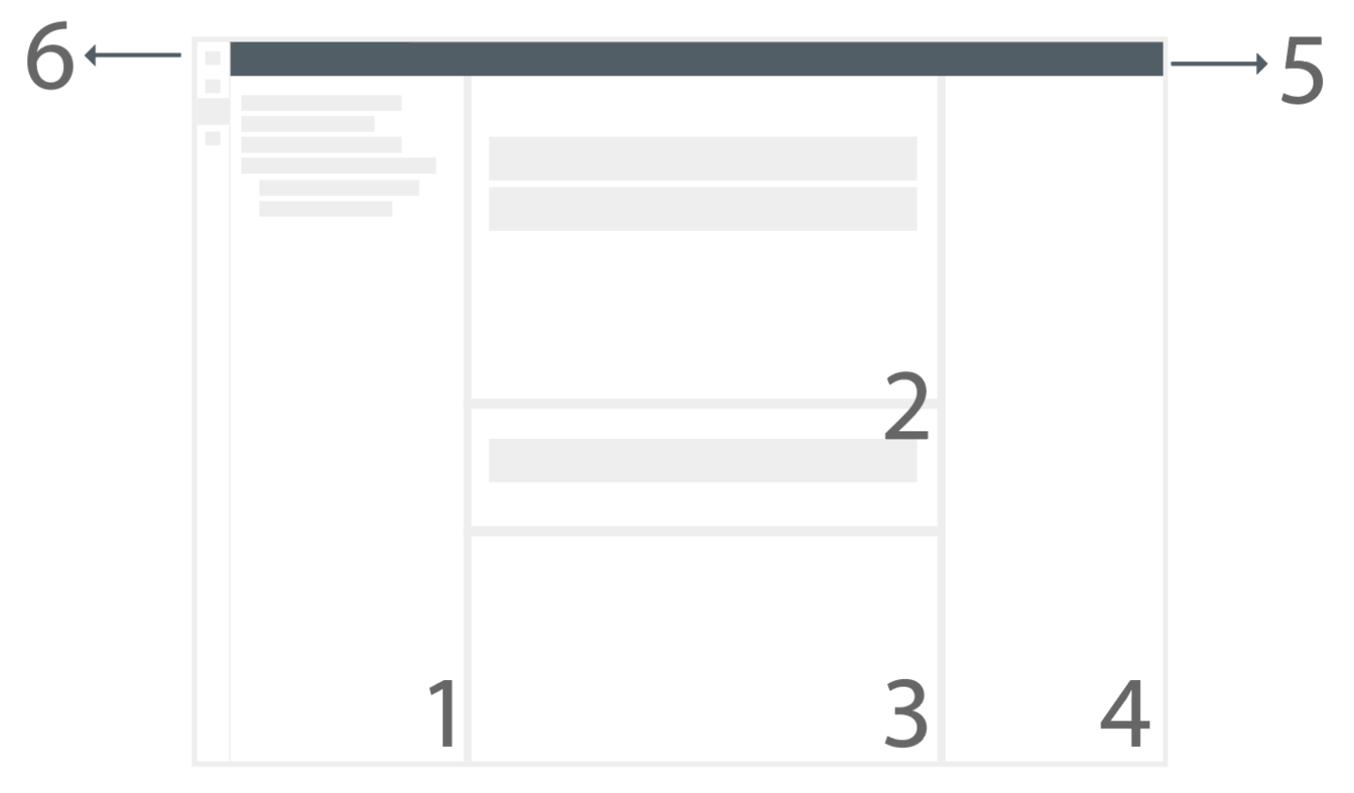

**Figure 1.** *Once RAVEN is loaded, the following containers will be displayed: (1) the Source Explorer, (2) the Bands Panels, (3) the Details Panel, (4) the Right Panel (5) the Top Bar and (6) the NEST Modules Navigation.*

###### Containers

Source Explorer Panel

The Source Explorer Panel displays the available data in a tree-like format. The user can navigate through the tree to select various data sources to visualize. Please refer to the Source Explorer Section for more details.

Bands Panels

RAVEN displays the data to visualize in the Bands Panels. These are: the Main Bands Panel and the South Bands Panel. When a source is selected from the Source Explorer, RAVEN will fetch its data and create a band that visualizes the contents. A band is added by default to the Main Bands Panel. The Main Bands Panel also contains the Time Band, the Time Management buttons and the Guides Management band, shown at **Figure 2**.

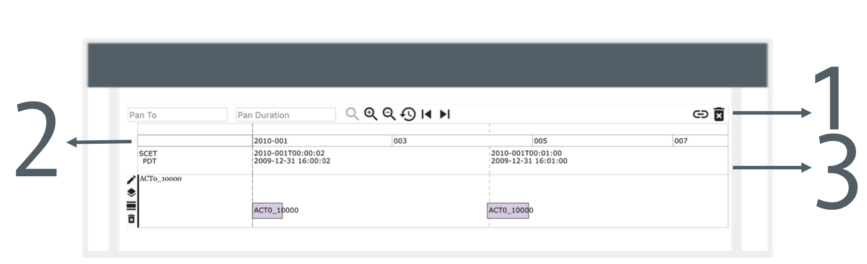

***Figure 2.*** *Once a source is selected, the band will be added to the Main Panel. The Main Panel also contains the Manage Graphs Menu, that includes the Time, States and Guides Management Buttons (1), the Guides Management Band (2) and the Timeline Band (3).*

Details Panel

When a band is selected from one of the Bands Panels, the Details Panel is populated with all the data points related to that specific source. The information provided includes: start time, end time, value of the data point, metadata, and more. When a data point is selected, the Details Panel will scroll to its location and highlight it.

Right Panel:

When a data point is selected, the Selected Point Panel will display more details about a data point. The information displayed will include: start time, end time, and value of the data point metadata.

Top Bar

The Top Bar contains the Global Band Settings, the Main Menu and options to manipulate the view. When bands are added, the Global Band Settings will configure default values. Some examples of this functionality include: changing the default line color, updating the width of the labels and more. Please refer to the Global Band Settings section for more detailed information.

The Main Menu displays options such as: Management of Output, Time Cursor, Epochs, and Situational Awareness.

##### Source Explorer

, **3**the PinsS

***3***

###### Source Explorer Iconography

There are different icons that represent every node in the Source Explorer tree. These can be expanded, collapsed and/or pinned. Others are graphable sources, which can result in a band that visualizes data.

|  |  |  |
| --- | --- | --- |
| Icon | Name | Description |
|  | Database | A data collection defined in the MPSServer configuration file. |
|  | Folder | These items store and organize uploaded files within a database. |
|  | Files | These are the individual files that are uploaded into folders using MPSServer. |
|  | Grouping | Source defined organization of graphable objects within uploaded files. |
|  | Graphable Source | Represents a source that can be rendered on the RAVEN timeline. |
|  | Custom Graphable Source | Represents a graphable source in where the user can pass a filter when requesting for data. |
|  | Unselected Source | When a graphable source contains this icon in the left side of its name, means that the source can be graphed. |
|  | Selected Source | When a graphable source contains this icon in the left side of its name, means that the source can be removed from the source explorer. |
|  | Filter | Represents a Sequence Tracker's Metadata Filter. When Sequence Events are selected and the user opens the Details Panel, the data point will have a Metadata Section with the selected filters. |
|  | Filter for Parent Graph | Represent Sequence Tracker sources. When the user adds them, they will all be drawn in the same Band. |

**Table 4**. Source Explorer Iconography.

###### Expand/Collapse Nodes

How To:

To expand a node:

1. Look for a collapsed Database, Folder or File source in the Source Explorer.
2. Click the source's name or the checkbox. As a result, the child sources of the selected one will be expanded, as shown at **Figure 4**.

How To: To collapse a node:

1. Look for an expanded Database, Folder or File icon in the Source Explorer.
2. Click the source’s name. As a result, the child sources will be collapsed.

***4***

###### How to display Source Metadata

1. Select a Database or Folder or File. The source will be highlighted and a snowman icon will appear.
2. Click the snowman icon
3. In the dropdown, select ‘Metadata’.
4. A drawer will open in the Source Explorer, showing more detailed information about the source.

###### Add/Delete Folders

A user can add or remove folders from the Source Explorer. These actions need to be performed from the Source Explorer itself or using our server API. **Note:** Creating custom sources using *mongodb* will not provide all the functionality delivered by Raven.

1. How to:

Add a folder

1. . In the dropdown, select: Add Folder.
2. A dialog will appear, enter the name of the new folder. Please note that
3. Click Add.

How to: Delete a folder

1. Select a Database or Folder or File. The source will be highlighted and a snowman icon will appear.
2. Click the snowman icon. In the dropdown, select: Delete.
3. A dialog will appear, confirming the desired action.
4. Click Yes.

###### How to: 'Graph Again' a source

'Graph Again' allows users to add the same source as much times as desired to the Bands Panel. This can be useful, for example, when a user wants to add the same source to different overlaid bands. To do so, a band should be already added.

1. Select a File. The source will be highlighted and a snowman icon will appear.
2. Click the snowman icon.
3. In the dropdown, select: ‘Graph Again’.

###### How To: Select a source

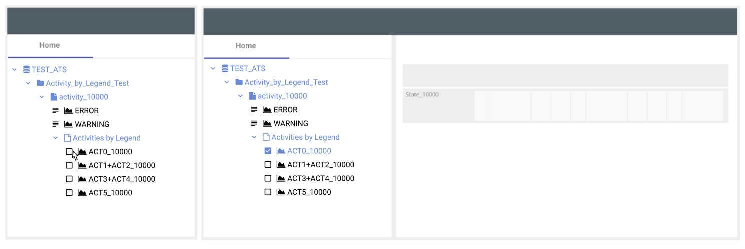

***Figure 5****. How to: Select a Source in the Source Explorer and add a Band. Left side: Navigate and click the Checkbox previous to a graphable source of your interest. Right side: The Checkbox will change its state to selected and a band will be added to the Main Bands Panel.*

To select a source in the Source Explorer:

1. Browse for a Graphable Source to display.
2. Click the Unselected Source name or checkbox to select the source.

As a result of your selection; a band is added to the Main Bands Panel.

###### Pins

A Pin is a subtree of the sources tree loaded in the Home Tab. It is used when a subtree is of special interest or requires quick and easy access. When a pin is created, a new tab will be added next to the *Home* tab in the *Source Explorer*, as shown on the **Figure 6**. If there are bands in the Bands Panels that are children of a pinned source, their labels will be attached with the pin name.

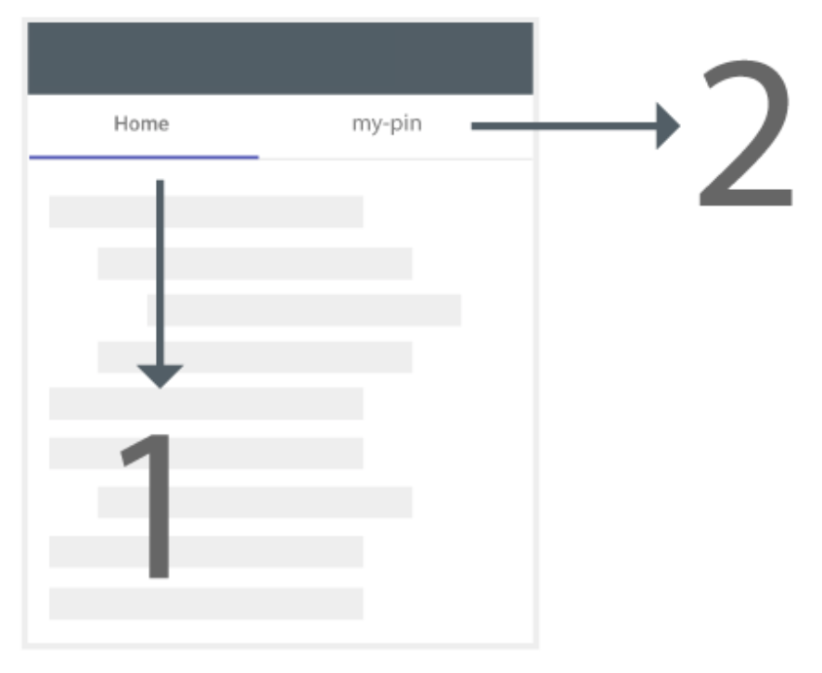

***Figure 6****. Pins: The (1) Home tab contains the original sources tree. When the user adds a new pin, for example (2) my-pin, it will represent a sub-tree out of the Home tab. To navigate to the content of the pin, click on its name in the Source Explorer's tab.*

How To: Pin a Subtree

1. Select a Database, Folder or File. The source will be highlighted and a snowman icon will appear.
2. Click the snowman icon.
3. In the dropdown, select: Add Pin.
4. A dialog will appear, enter the name of the new pin.
5. Click Add.

How To: Rename a pin

1. Select a Database, Folder or File that is pinned already. It can be selected from the Home Tab or the Pin's Tab.
2. The source will be highlighted and a snowman icon will appear.
3. Click the snowman icon.
4. In the dropdown, select: Remove Pin
5. A dialog will appear, click: Remove.

###### Filtering the source tree

How To: Apply a filter

1. Input a regular expression into the filter panel.
2. Click the ‘Search’ button in the filter panel.
3. The source tree will be pruned: only items whose name matches the regular expression, folders containing those items, and files contained in those items will remain visible.

How To: Remove a filter

1. Clear any input in the filter panel.
2. Click the ‘Search’ button in the filter panel.
3. The source tree will display all items, regardless of their names.

###### Import CSVs, Epochs or PEFs

RAVEN allows the user to add sources from the user interface.

How To: Import

1. Identify where in the Source Explorer you want to add the new source. In the parent of that location, hover the source to show the snowman icon. Click the snowman icon.
2. In the dropdown select `Import`. A dialog will appear.
3. Fill the form:
   1. Enter the name of the source that will appear in the Source Explorer.
   2. Select the file type, options are: CSV, Epoch and PEF.
   3. Select the file that will be imported from your computer. Please note that when importing a CSV, you will need a mapping file as well.
4. Click Import.
5. The file will be imported and appear in the desired location. Please note that sometimes the source does not appear immediately, if so, please refresh the page. This is a known issue that might be addressed in a future.

##### Bands

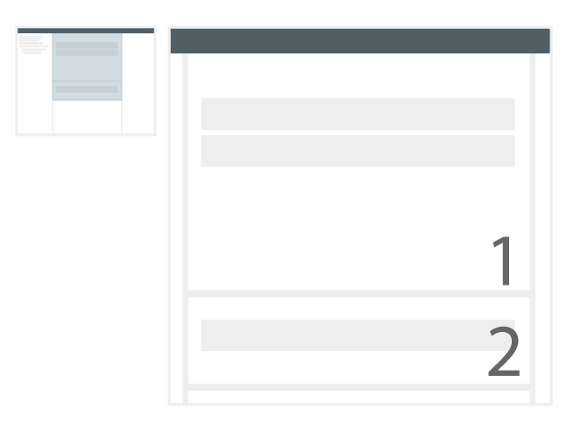

***Figure 7****. Bands represent the selected sources in the Source Explorer, displaying one or more data sources per band. There are two panels: (1) the Main Bands Panel and the (2) the South Bands Panel. There is also a Manage Graphs Menu. The user can move the bands between both panels and arrange their order if desired.*

A band is how the timeline data is presented within RAVEN. When a data source is selected a band is added to the Main Bands Panel and its data is displayed. There are three different band types that the user can add: Activity, Resource and State Bands which are shown at **Figure 8**.

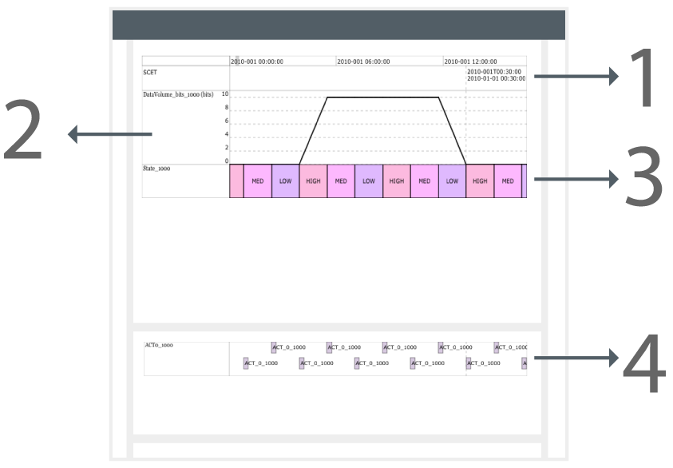

***Figure 8****. Bands represent the selected sources in the Source Explorer, displaying one or more data sources per band. There are two panels: (1) the Main Bands Panel and the (2) the South Bands Panel. The user can move the bands between both panels and arrange their order if desired.*

Each band type has its own settings that can be modified. In order to perform this action, you need to select a band and the right panel will show the available configuration options.

###### How to: Select a Band

Given a band exists in the Bands Panel, click the band in the label area. Selecting a band will trigger the following actions: a dark line will appear at the left side of the band; The Details Panel will populate a table with the source's data points; and icons to manage the band will appear.

Band Menu Icons

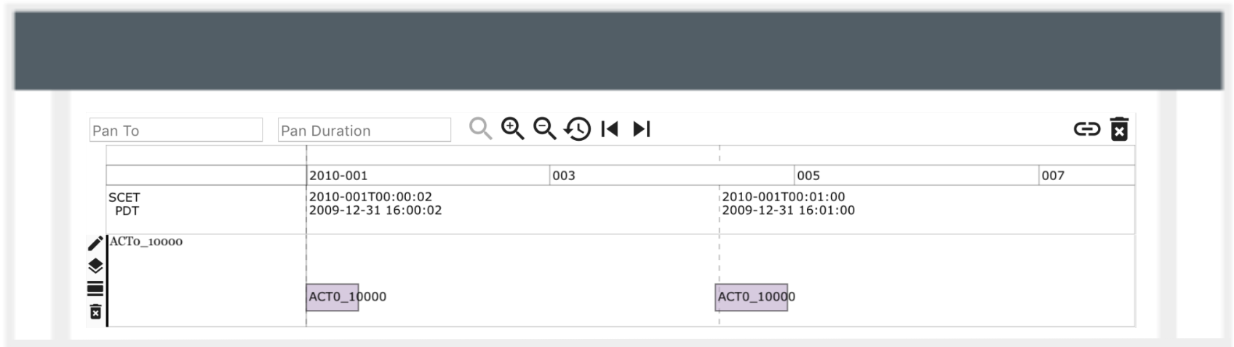

***Figure 9****. When a band is in the Bands Panel and the user hovers/selects a band, the Manage Band Icons are shown at the left side of the band appear. These icons provide access to the Band’s settings, Overlay/Add-to, Add Dividers and Delete Band.*

How To: Open Band Settings

1. Select/Hover a band, the Manage Band Icons will appear.
2. Click the Pencil icon.
3. A dialog will open showing all the Bands Settings Options.

For more information about the available options, reefer to the *Band Configuration Options by Type* section.

How To: Overlay Bands

Overlaying bands allows for multiple data sources of any type to be overlaid within the same timeline band. To overlay multiple bands:

1. Select/Hover a band, the Manage Band Icons will appear.
2. Click the Overlay Icon (the second icon from the top), and this icon will change from grey to blue.
3. Select a source from the Source Explorer. The selected source will be added in the same band from step one.

**Note:** When a band is overlaid, the Band Configuration Options for that band will add a Selected Sub-Band option. This will allow the user to change the properties of both overlaid sources. In the case that the user uses 'Add To' instead of 'Overlay' this option will not be provided, since the data points for both sources will exist in the same band.

How To: ‘Add To’ Bands

'Add To' is similar to overlaying bands, however is specific for Activity Bands. The activities will be added in line with different activity sources within the same band. The activities will not overlap each other and be arranged as if the activities were drawn from a single data source.

1. Select/Hover a band, the Manage Band Icons will appear.
2. Click the Overlay Icon (the second icon from the top) twice, and this icon will change from grey to blue and from blue to yellow showing a plus icon.
3. Select another source of your preference. The data points of this last selected source will be added in the same band from step one.

How To: Add Divider Bands

Divider bands are use as separators of different band groupings. If the user wants to add a band in a specific location, a band can be selected and when the user adds a band it will be added after the selected band.

1. Select/Hover a band, the Manage Band Icons will appear.
2. Click the Divider Icon (the third icon from the top)
3. A divider band will be added in the bands panel.

How To: Delete a Band from the Bands panel

The user can perform a band deletion in two different ways. This procedure is specific to the Manage Band Icons option.

1. Select/Hover a band, the Manage Band Icons will appear.
2. Click the Trash Can icon.
3. A dialog will appear to confirm the action.

###### Global Settings

The global settings will apply to all the bands once the options are changed.

|  |  |
| --- | --- |
| **Option** | **Description** |
| **Label Width** | Defines the width of the label area for each band. |
| **Show Tooltip** | If On, the tooltip will be displayed. The tooltip appears in three areas: the band's label area, timeline band and for each the data point when hovering the band. |
| **Show Last Click** | If On, when the user clicks any band at any point in the timeline, it will add a light blue 'ghost' line marking the selected time. |
| **Default Activity Layout** | Sets the default value for the activity layout when activities are added in the future. |
| **Label Font Size** | Defines the Font Size for the label of each band. |
| **Default Label Font** | Defines the font of the label for each band. |
| **Default Resource Color** | Sets the default value for the line color when resources are added in the future. |
| **Default Resource Fill Color** | Sets the default value for the fill color when resources are added in the future. |
| **Default Icon** | Sets the default icon for when activities and resources are added in the future. |

**Table 5**. Global Settings Options.

###### Band Configuration Options by Type

Common Options

|  |  |
| --- | --- |
| **Option** | **Description** |
| **Source** | Provides the path reference from the source. |
| **Label** | Defines the label displayed in the Band |
| **Height** | Defines the height of the band. |
| **Delete Band** | To delete a band, the user should click the Trash Can Icon. |
| **Show Pin Label** | If this option is Turned On and the selected source is the child of a pin, it will append the pin name to the band's label. |

**Table 6.** Common Band's Settings. Divider Band only has the Label and the Height options.

Divider Bands Options

|  |  |
| --- | --- |
| Option | Description |
| **Background Color** | Sets the background color of the divider. |

**Table 7.** Divider Band Settings.

Resource Bands Options

|  |  |
| --- | --- |
| Option | Description |
| **Unit Label** | Defines the unit label that is appended to the band's label. |
| **Show Unit Label** | If this option is Turned On, the Unit label will be appended to the band's label. |
| **Auto Scale** | If this option is Turned On, it will calculate the y-Axis ticks based on the current range view. |
| **Line Color** | Defines the color of the resource's line. |
| **Fill** | If this option is Turned On, it will fill the chart from the line to the bottom. Turning this option on, will show the Fill Color Option. |
| **Fill Color** | Defines the color of the resource's fill. |
| **Interpolation** | Defines the interpolation of the chart. Options: Constant, Linear and None. |
| **Log Scale** | If this option is Turned On, it will calculate the log for all the data points and graph them. Turning this option on, will hide the Scientific Notation Option. |
| **Scientific Notation** | If this option is Turned On, the yAxis ticks will be represented with scientific notation. Turning this option on, will hide the Log Scale Option. |
| **Show Icon** | If this option is Turned On, icons will be show for each data point. Turning this option on, will show the Icon Option. |
| **Icon** | If Show Icon is On, the selected Icon will be the one displayed for each data point. Options: None, Plus, Cross, Circle, Triangle, Square and Diamond. |
| **Composite Y-Axis Label** | If this option is Turned On and if there are two or more resource band types overlaid, then the Y-axis will work as a one. In addition, options like Scientific Notation, Log Scale and Auto Scale will be applied to the composite y-axis. |

**Table 8.** Resource Band Settings.

State Bands Options

|  |  |
| --- | --- |
| Option | Description |
| **Horizontally Align Label** | Will align the label of each data point horizontally. Options are: Left and Center. |
| **Vertically Align Label** | Will align the label of each data point vertically. Options are: Top, Bottom and Center. |
| **Show State Change Times** | If this option is Turned On, it will append the state times at the bottom of each state. |
| **Plot Type** | Defined how the states are represented in the band. Options: Bar and Line. |

**Table 9.** State Band Settings.

Activity Bands Options

|  |  |
| --- | --- |
| Option | Description |
| **Layout** | Defines how the activities are displayed in the Band. Options are (1) Autofit (2) Waterfall and (3) Packed. |
| **Activity Style** | Defines how the data points will be displayed. Options are (1) Bar, (2) Icon and (3) Line. |
| **Horizontally Align Label** | Will align the label of each data point horizontally. Options are: Left and Center. |
| **Vertically Align Label** | Will align the label of each data point vertically. Options are: Top, Bottom and Center. |
| **Show Activities Times** | If On, it will show at what time an activity starts and ends in the bottom of the activities. |
| **Show Labels** | If On, labels will be shown for each data points. |
| **Activity Label Font Size** | Defines the size of the label of all the activities in the band. |

**Table 10.** Activity Band Settings.

###### Manage Graphs Menu: Time Management Buttons

When a band exists in the Main Bands Panel, the Time Management Buttons appear above the Time Band, along with the Guides and the State Management buttons, which will be discussed in further sections. There are different ways to change the view range for your bands. From the Manage Graphs Menu you can execute Pan To, Zoom In/Out, Pan Left/Right, and Reset Time. From the Time Band you can brush and execute pan, and also move the view frame among the entire band's frame.



***Figure 10****. The Time Management Buttons contains the 'Pan To' Options, Zoom In/Out, Reset Time and Pan Left/Right.*

How to: Pan To

To Pan to a specific location on the timeline,

1. Enter the start time in the 'Pan To' input field located in the Manage Graphs Menu.
2. Enter the desired 'Pan Duration' for the view range. As a result, the end time will be equal to the start time + duration.
3. Click the magnifier icon.

How to: Zoom In/Out

* To 'Zoom In', click the Zoom in Icon in the Manage Graphs Menu.
* To 'Zoom Out', click the Zoom out Icon in the Manage Graphs Menu.

How to: Reset Time

To 'Reset Time', click the Reset Time Icon in the Manage Graphs Menu.

How to: Pan Left/Right

* To 'Pan Left', click the Left Arrow Icon in the Manage Graphs Menu.
* To 'Pan Right', click the Right Arrow Icon in the Manage Graphs Menu.

How to: Execute brush from the timeline

As shown at **Figure 11**, to zoom your view range from the timeline bar,

1. Click and hold in the timeline bar where you want the view range to start.
2. Move the cursor left or right defining the length of the view range that you desire.
3. Release the cursor.

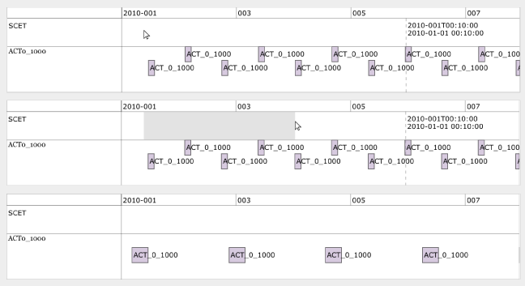

***Figure 11****. How to: Execute Brush in the Timeline. Top side: Click and hold at any place where you want to start or end your view range. Middle Side: Move your cursor left or right and release the cursor once the desired duration is selected. Bottom side: All the bands in the Bands Panels will update their view based on the user's selection.*

###### Other features available in the Bands Panel

How to: Select a Data Point

To select a Data Point, click on the data point of your preference from the band. When a data point is selected, the 'Selected Point' Tab will display more details about the data point. Provided data will include start time, end time, value of the data point metadata and more.

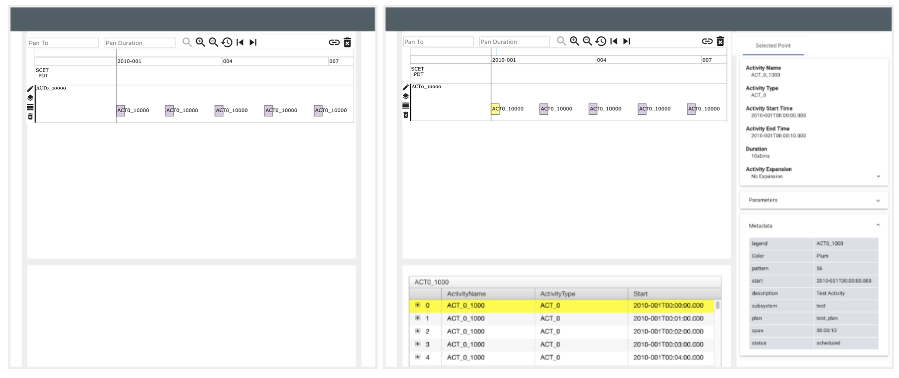

***Figure 12.*** *Select a Data Point. Left side: On a band of your preference, click any data point. Right Side: Once a data point is selected, the details panel will scroll and highlight the selected data point. Also, within the 'Selected Point' Tab in the Right Panel, the data point's metadata will be displayed.*

How to: Remove all Bands

To remove all the drawn bands:

1. From the Manage Graph Menu click the Trash Can icon to Remove All Bands.
2. A confirmation dialog will appear.
3. Click Yes. All bands should be removed.

How to: Expand Activity Data Points

1. Make sure that you have an activity band in the band’s panels.
2. Select an activity data point in the band.
3. In the Selected data Point Panel, look for the Activity Selection Dropdown, there are three options: No Expansion, Children Expansion and Descendants Expansion, **Table 11** shows more details about each option.
4. Select the desired expansion.

|  |  |
| --- | --- |
| Option | Description |
| **No Expansion** | Displays only the parent activity. |
| **Children Expansion** | Displays the immediate children of the selected activity. |
| **Descendants Expansion** | Displays all the descendants of the selected activity (Children of Children). |

**Table 11.** Activity Expansion Options.

##### Guides

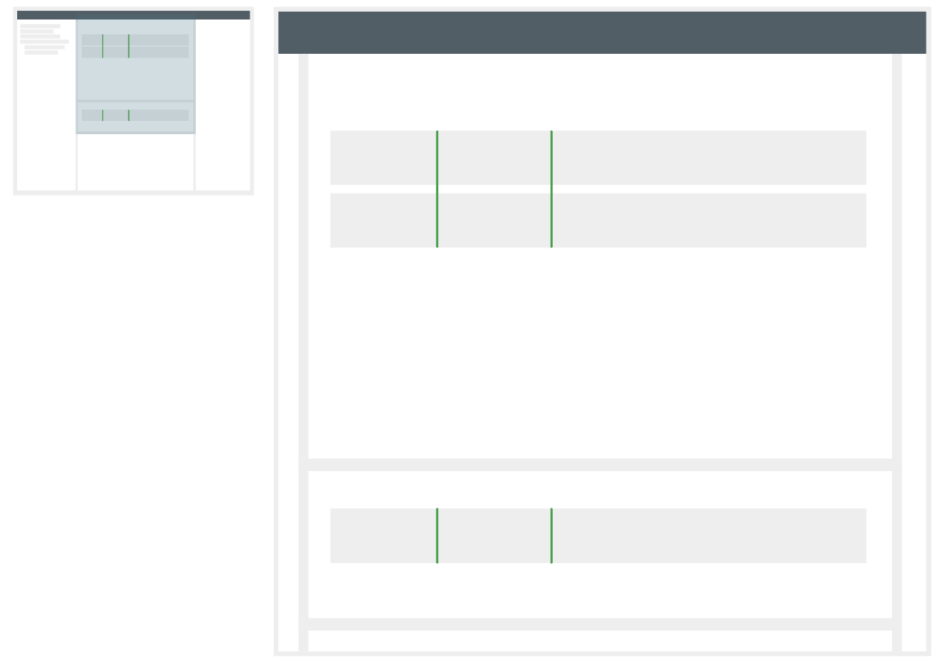

***Figure 13.*** *Guides are green lines across all the data bands in the Bands Panels.*

Users can add guides to mark a point in time to all the data bands drawn in the Bands Panels. The user can turn on the Show Last Click option in the Global Band Settings panel. If Show Last Click is on, when the user clicks any band at any point in the timeline, it will add a Ghost Line marking to the selected time as shown in **Figure 14**. It is important to note that the Ghost Line is not the guide itself, as guides are coloured green and exhibit permanence.

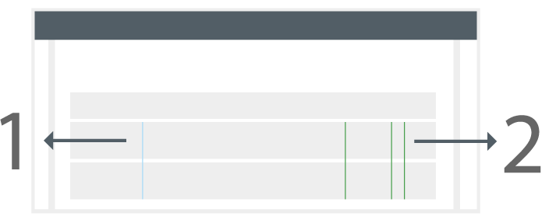

***Figure 14.*** *Guides and Ghost Line. (1) Guides are represented with green lines crossing all drawn bands. (2) The Ghost Line will be displayed if the user clicks at any time and has the Show Last Click Option On. The Ghost Line is represented with a light blue line across all drawn bands.*

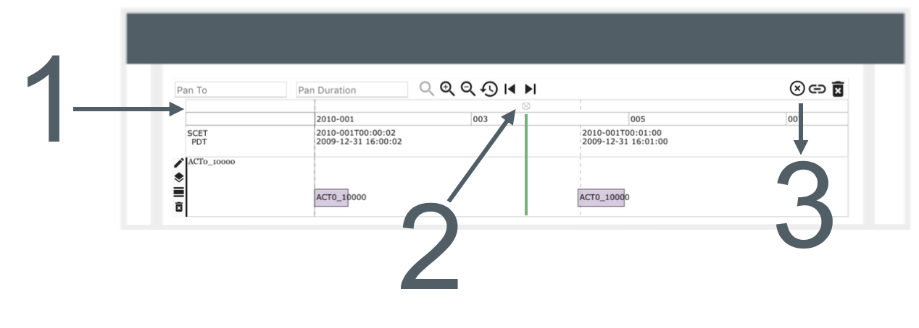

***Figure 15.*** *When a band exists in the Bands Panel, the Guides Band (1) is visible as well. The user can click at any point in the Guides Band and a green guide will be added automatically across all the bands. To remove an individual guide, the user can click the ‘x’ icon on top of a guide (2) and it will be removed from the view. If the user wants to remove all the guides, the Graphs Management Menu will show a Remove All Guides (3) button.*

###### How to: Add a Guide

1. In the Guides Band, click at any point in time. A green guide will be added to the bands.

###### How to: Delete a Guide

1. Click the ‘x’ icon that is shown at the Guides Band. The guide will be removed.

###### How to: Delete All Guides

1. In the Manage Graphs Menu, click the Remove All Guides icon.
2. A confirmation dialog will appear.
3. Click Yes. All guides should be removed.

##### Time cursor

The time cursor marks the time passing amongst all the bands in the timeline. It will be represented with a line and move at the defined rate through the timeline.

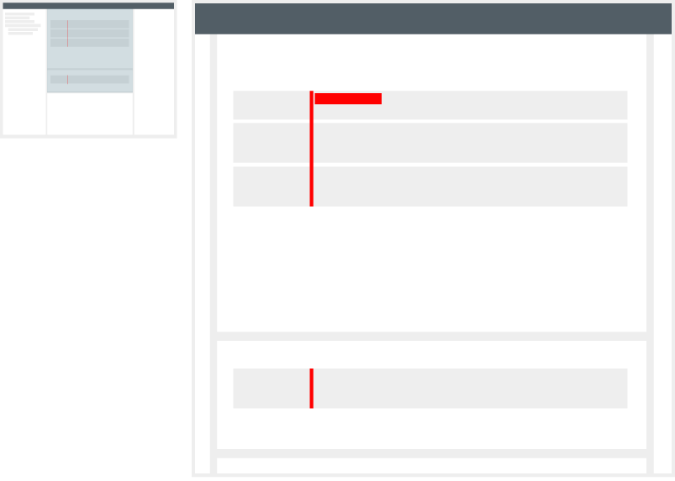

***Figure 16.*** *Time cursor displayed among all the bands in the main and south Bands panels.*

###### How to: Add a Time Cursor

1. Add a band. To do so, select a graphable source in the Source Explorer.
2. In the Top Bar, open the Main Menu by clicking the snowman icon.
3. In the Dropdown, select the 'Manage Time Cursor' option.
4. A new drawer is displayed with the Time Cursor options.
5. Toggle 'Show Time Cursor'. By default, if the 'Set Current Cursor Time' is not defined, RAVEN will use the actual current time.

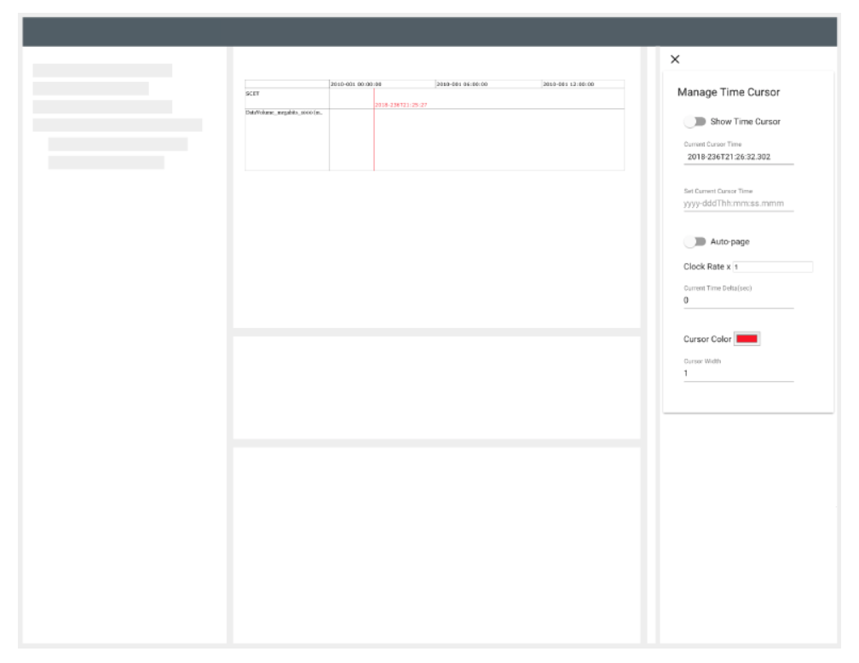

***Figure 17.*** *Time cursor added in the application. Note that in the left side of the application a drawer to Manage Time Cursor is opened. 'Other Options Section' will provide details.*

###### Other options

|  |  |
| --- | --- |
| Option | Description |
| **Show Time Cursor** | Will toggle the view of the time cursor in the timeline. |
| **Current Cursor Time** | Defines where in the timeline the time cursor is. By default, it will be set to the actual current time. |
| **Set Current Cursor Time** | Allows the user to manually enter where the time cursor will start. |
| **Auto-Page** | If On, as the time cursor reaches the right side of the timeline, the time range will update so the time cursor is always visible. |
| **Clock Rate** | Defines the rate at which the cursor moves through the timeline. |
| **Current Time Delta** | When the time cursor doesn't have a manual 'Set Current Cursor Time' value defined, the value assigned in this field will be added to the actual current time. |
| **Cursor Color** | Defines the color of the cursor. The default color is red. |
| **Cursor Width** | Defines the width of the cursor. |

**Table 12.** Time Cursor Settings.

##### States, Layouts and Shareable Links

When the user desires to save and recover their data display in a future; states, layouts and shareable links provide this functionality.

###### States

A state saves all the bands, bands options, view range and all the items that the user added and customized at the moment a state was saved. A user can save their state anywhere in the source tree where allowed to do so.

How to: Save a State

1. Select a Database.
2. Click the snowman icon.
3. In the dropdown, select: 'Save'.
4. A dialog will open requesting a name for the state.
5. Click 'Save'. In the selected database the state should be added with the designated name.

How to: Apply as a State

1. In the Source Explorer browse for a state to load.
2. Select the item, to do so click on its name.
3. Click the snowman icon.
4. In the dropdown, select 'Apply'.
5. Another dropdown will be displayed, select 'State'.
6. A dialog will appear asking for permission to remove the current state of the application. Press Yes to proceed. All the bands, the view range and the customized options will be restored.

When a State is saved or applied, the State Management Buttons will appear in the Manage Graphs Menu as shown at **Figure 18**. The user will be able to Apply a Layout, Revert and Save a State from these buttons as well from the Source Explorer.

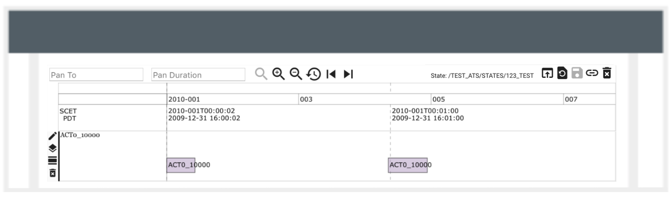

***Figure 18.*** *The State Management Buttons include the path of the State, an Apply Layout Button, a Revert State Button and a Save State Button.*

How to: Update a State from the Source Explorer

1. Create a new state to host the result of the existing state.
2. Select a Database where the state that you want to update is contained.
3. Click the snowman icon.
4. In the dropdown, select: Save.
5. A dialog will enter the same name of the state that you want to update. A warning of rewriting will be displayed.
6. Click Save. The state should be updated.

How to Update the State from the State Management Buttons

When a state is already applied the user can add or remove sources or change any configuration of the bands. If the user wants the applied state to inherit these changes, the user should click the Update State button from the State Management Buttons.

How to Revert a State from the State Management Buttons

When a state is already applied the user can add or remove sources or change any configuration of the bands. If the user wants to revert the changes and return to the original state, the user should click the Revert State button from the State Management Buttons.

How to: Remove a State from the Source Explorer

1. Browse in the Source Explorer for a state.
2. Select the item by clicking on its name.
3. Click the snowman icon.
4. In the dropdown, select: Delete.
5. A dialog will appear prompting for permission to proceed. Press Yes to continue.

###### Layouts

Some of the available collections or databases share the same structure. A state can be saved as a template to apply the same options from another collection or database. Example:

+-- Collection-a

| +-- source-a

| +-- source-b

+-- Collection-b

| +-- source-a

| +-- source-b

both Collection-a and Collection-b contain sources with the same names. Assume there exists a state, let's call it example-state, that contains the band: Collection-a > source-a. If the user wants to apply the same structure to Collection-b, then the user can apply example-state as a layout to Collection-b. The result will be that the only band that will is added to the ‘Bands Panel’: Collection-b > source-a.

How to: Apply a state as a layout via Source Explorer

1. Browse the Source Explorer for a state.
2. Open the nodes for the sources that you want to apply this state as a layout.
3. Select the item by clicking on its name.
4. Click the snowman icon.
5. In the dropdown, select: Apply.
6. Another dropdown will be displayed, then select Layout.
7. A drawer will appear in the right-hand side of the application as shown at **Figure 19**.
8. A dropdown will show, displaying states and opened sources in the source explorer. Select the sources.
9. Click Apply.
10. A dialog will appear prompting for permission to proceed. Click Yes to continue.

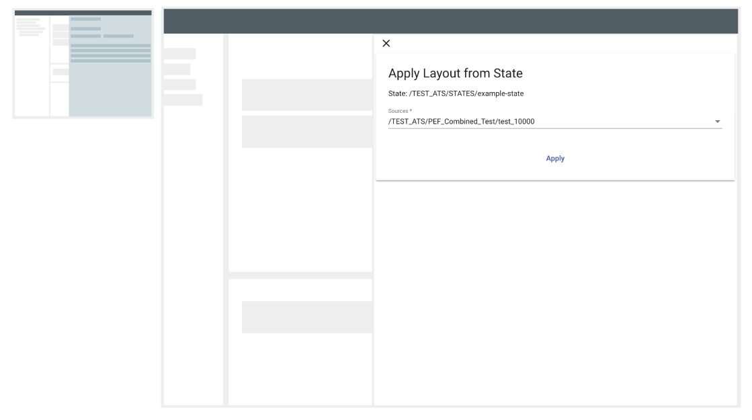

***Figure 19.*** *Apply as a layout drawer. When the user desires to apply a state as a layout, the drawer showed in the right side of the application will appear. In the Sources dropdown, the user will be able to select all the sources to which the layout is desired to be applied.*

How to: Apply a state as a layout from the State Management Buttons

1. Click the Apply Layout button from the State Management Buttons.
2. Follow the steps 7-10 from the ` How to: Apply a state as a layout via Source Explorer`

How to: Apply a state as a layout using URL

In order to apply a state as a layout using URL, the user needs:

1. Path of the state. *(<STATE_PATH>)*
2. Path of the sources that the user wants to apply layout to. (<SOURCE_A>, …, <SOURCE_N>)
3. The URL will look as follows:

*<LINK_TO_RAVEN>?layout=<STATE_PATH>&source=<SOURCE_A>, …, <SOURCE_N>*

**Important Note:** Pins are not supported by applying a state as a layout via URL.

###### Shareable Links

Shareable links helps with the creation of states and their access. When the user wants to share their view with another user a Shareable link can be used.

How to get a Shareable Link

1. In the Manage Graphs Menu, click the Shareable Link Icon.
2. A dialog to copy the Shareable Link will appear.
3. By default, RAVEN will create a random id to generate the Shareable Link. The user also has the option to rename the shareable link. (**Figure 20**)
4. Once the shareable link is defined, copy the generated link. When it is in the clipboard, dialog will close automatically.
5. Now, you can open your link in your browser's tab or share it with a college.

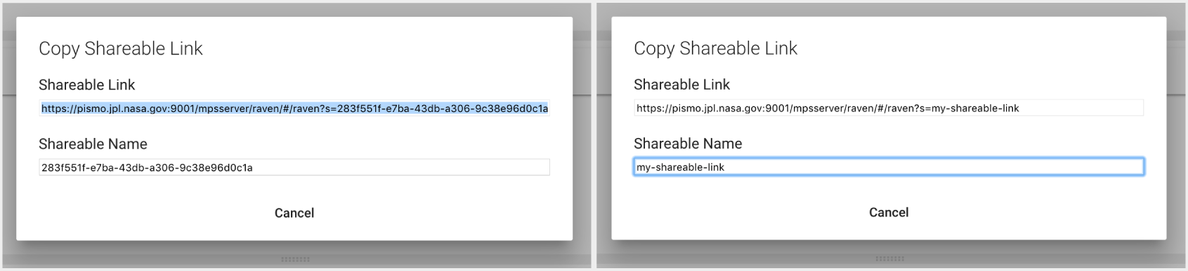

***Figure 20.*** *Shareable link dialog. A Shareable Link with a generated unique identifier. (left) A Shareable Link with custom name entered by the user. (right)*

A host folder for the shareable link is defined on RAVEN's settings section. Since a shareable link is a state, the user can access it in the future to load it, update it, and/or delete it.

##### Export Data

###### How to: Export your data

1. Make sure that the data sets you want to download are selected in the Source Explorer.
2. In the Top Bar, open the Main Menu and in the Dropdown select 'Manage Output'.
3. A drawer will open showing a list of the sources available to download.

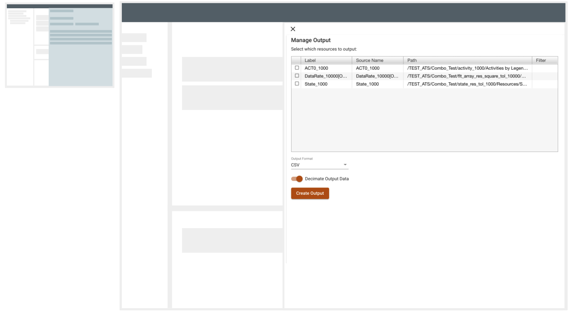

***Figure 21****. Manage Output Drawer. In order to download the data of a selected source, select the it in the table, pick a format and generate the output.*

1. A table will be displayed with all the selected sources in the application, check the ones to export.
2. Select the format of the file and whether you want the data to be decimated or not.
3. Click Create Output. A file will start downloading.

###### How to: Export your data in ‘All-in-one’ file

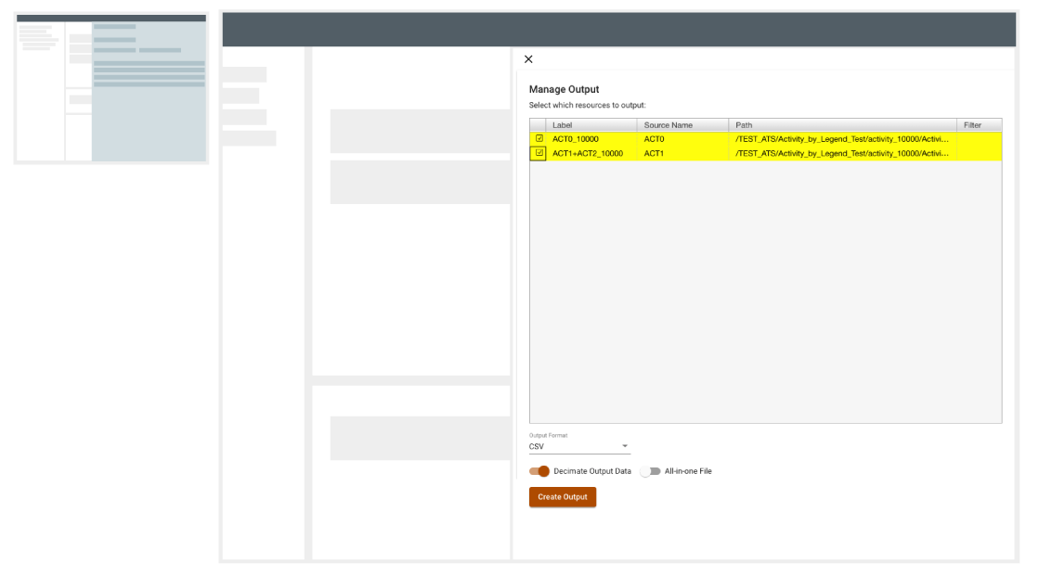

***Figure 22****. Manage Output Drawer. When the user selects more than one source, the All-in-one File option will be available.*

1. Make sure there are two or more data sets selected in the Source Explorer.
2. In the Top Bar, open the Main Menu by clicking on the snowman icon.
3. In the Dropdown select: Manage Output.
4. The Manage Output drawer will open showing a list of the available sources to download.
5. A table will be displayed with all the selected sources in the application, check at least two files.
6. Set the All-in-one File true.
7. Enter the name for the new file as shown at **Figure 23**.
8. Click Create Output. Your file will start to download.

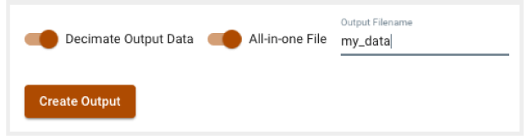

***Figure 23****. When the All-in-one File option is set to true, the user needs to enter a name for the file. Once entered Create Output will be enabled.*

##### Situational Awareness

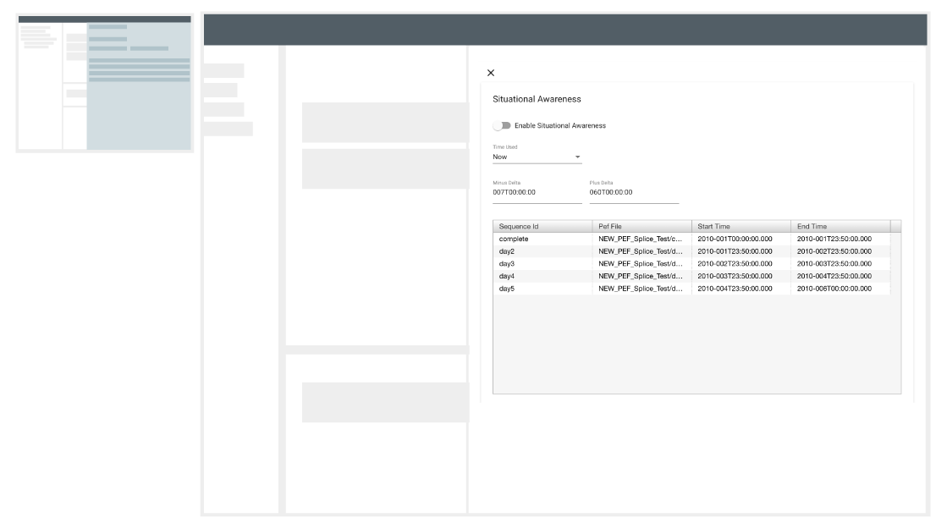

***Figure 24****. Situational Awareness Drawer. Situational awareness will read the available sequences and show them to the user.*

Situational Awareness is a mode in RAVEN which allows the timelines to be displayed based on current time or a user specified time. If the current time is selected, the user can specify the plus and minus deltas to provide the page duration. The default minus delta is 7 days and plus delta is 60 days. Hence, the default page duration is 67 days.

In situational awareness mode, RAVEN will only query data for the current time period resulting in an improved performance for timelines spanning a long period. In addition, PEF data can be setup on the server side to be 'stitched' from multiple sequences. Querying PEF data in situational awareness mode will result in portions of timeline data from multiple PEFs stitched together as one continuous timeline rendered in RAVEN.

###### How To: Enable situational awareness

1. In the Top Bar, open the Main Menu by clicking on the ‘snowman icon'.
2. In the Dropdown select: ‘Situational Awareness’.
3. As shown on **Figure 24**, the ‘Situational Awareness’ drawer will appear.
4. Situational Awareness can be enabled in two ways:
   1. Setting Start Time to Now
      1. The ‘Time Used’ dropdown should be set to ‘Now’ which is the default value.
      2. There are two input fields: ‘Minus Delta’ and ‘Plus Delta’.
         1. ‘Minus Delta’ is the time that will be subtracted from the current time.
         2. ‘Plus Delta’ defines the desired duration after the current time.
      3. As a result, in the view range:
         1. start time = current time - minus delta
         2. duration = minus delta + plus delta
   2. Setting a Custom Start Time
      1. Change ‘Time Used’ to ‘Input Time’.
      2. There are two input fields: ‘Start Time’ and ‘Duration’
         1. ‘Start Time’, defines the start time for the view range
         2. ‘Duration’, defines the duration after the start time for the view range.
5. Set ‘Enable Situational Awareness’ to True. A new band will be added to the timeline with blocks that represent each sequence available to the user, like the one on **Figure 25**. And the range of the bands will be changed to the defined one on step 4.

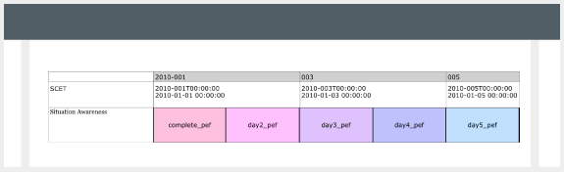

***Figure 25****. Situational Awareness Band. Once Situational Awareness is enabled, a Situational Awareness Band will be added as a map of the available sequences.*

##### Epochs

When the user desires to use Epochs, this will be shown in the Time Band as well in the Tooltip when a data point is hovered. An Epoch can be uploaded following the steps from the ‘Import CSVs, Epochs or PEFs’ section.

###### How To: Load an Epoch

1. Once an Epoch is available in the Source Explorer, hover or select the source and click the snowman icon.
2. In the dropdown select, Load Epoch.

###### How To: Select an Epoch

1. From the menu in the top bar, select the snowman icon.
2. In the dropdown select, Manage Epochs.
3. A drawer will be displayed, select the desired Epoch from the table.